A Major Project Report on

# A GRAPH NEURAL NETWORK BASED HYBRID MODEL

# FOR GENERATIVE AI AUTHORSHIP VERIFICATION

Submitted in partial fulfilment of the requirements for the award of the degree of **Bachelor of Engineering**

in

**Computer Science and Engineering**

By

**SRI KRISHNA CHAITANYA DIVAKARUNI 1608-21-733-006**

**RUPA SREE CHENUMOLU 1608-21-733-025**

## HRISHI DURKI 1608-21-733-052

**Under the guidance of**

**Dr.T.Raghunadha Reddy**

**Associate Professor & H.O.D**



**DEPARTMENT OF COMPUTER SCIENCE AND ENGINEERING**

**Matrusri Engineering College**

**Accredited by NBA & NAAC**

**(Affiliated to Osmania University, Approved by AICTE)**

**Saidabad, Hyderabad-500059** **(2024-2025)**

# Department of Computer Science and Engineering Matrusri Engineering College

**Accredited by NBA & NAAC**

(Affiliated to Osmania University, Approved by AICTE)

Saidabad, Hyderabad-500059

(2024-2025)



# CERTIFICATE

This is to Certify that A Mini Project report entitled **“A GRAPH NEURAL NETWORK BASED HYBRID MODEL FOR GENERATIVE AI AUTHORSHIP VERIFICATION**” is being submitted by Sri Krishna Chaitanya Divakaruni **(**1608-21-733-006**),** Rupa Sree Chenumolu **(**1608-21-733-025**),** Hrishi Durki(1608-21-733-052) in partial fulfilment of the requirement of the award for the degree of Bachelor of Engineering in “Computer Science and Engineering” O.U., Hyderabad during the year 2024-2025 is a record of bonafide work carried out by them under my guidance. The results presented in this project have been verified and are found to be satisfactory.

**Project Guide** **H.O.D**

**Dr.T.Raghunadha Reddy**  **Dr.T.Raghunadha Reddy**

Associate Professor & H.O.D Associate Professor & H.O.D

Dept. of CSE Dept. of CSE

## External Examiner(s)

## Department of Computer Science and Engineering Matrusri Engineering College

**Accredited by NBA & NAAC**

(Affiliated to Osmania University, Approved by AICTE) Saidabad, Hyderabad-500059

(2024-2025)



### DECLARATION

We, Rupa Sree Chenumolu **(**1608-21-733-025**),** Sri Krishna Chaitanya **(**1608-21-733-006**),** Hrishi Durki (1608-21-733-052) hereby certify that the minor project entitled “**A GRAPH NEURAL NETWORK BASED HYBRID MODEL FOR GENERATIVE AI AUTHORSHIP VERIFICATION**” is submitted in the partial fulfilment of the required for the award of the degree of Bachelor of Engineering in Computer Science and Engineering.

This is a record work carried out by us under the guidance of Dr.T.Raghunadha Reddy, Associate Professor, CSE, Matrusri Engineering College, Saidabad. The results embodied in this report have not been reproduced/copied from any source. The results embodied in this report have not been submitted to any other university or institute for the award of any other degree or diploma.

Sri Krishna Chaitanya Divakaruni - 1608-21-733-006

Rupa Sree Chenumolu - 1608-21-733-025

Hrishi Durki - 1608-21-733-052

### ACKNOWLEDGEMENT

It is our privilege and pleasure to express my profound sense of respect, gratitude and indebtedness to our guide **Dr.T.Raghunadha Reddy**, Associate Professor, Department of Computer Science and Engineering, Matrusri Engineering College, for his inspiration, guidance, cogent discussion, constructive criticisms, and encouragement throughout this dissertation work.

We express our sincere thanks to Project Coordinator **Dr.Raghavendra Raju L** Associate Professor, Department of Computer Science and Engineering, Matrusri Engineering College, for her valuable suggestions and constant helping in completing the work.

We express our sincere gratitude to **Dr.T.Raghunadha Reddy**, Associate Professor & Head of the Department of Computer Science and Engineering, Matrusri Engineering College, for his precious suggestions, motivation, and co-operation.

We express our sincere thanks to **Dr. G. Amarendhar Rao**, Principal, Matrusri Engineering College, Saidabad, Hyderabad, for his encouragement and constant help.

We extend our sincere thanks to all the teaching and non-teaching staff of Computer Science and Engineering Department for their support and encouragement.

Last but not least, we wish to acknowledge my friends and family members for giving moral strength moral strength and helping us to complete this dissertation.

Sri Krishna Chaitanya Divakaruni - 1608-21-733-006

Rupa Sree Chenumolu - 1608-21-733-025

Hrishi Durki - 1608-21-733-052

#### ABSTRACT

The proliferation of advanced AI language models has made it increasingly challenging to distinguish between human-written and AI-generated text. This project, "AI vs. Human Text Authorship Detection and Comparison," addresses this challenge by developing a web-based application that analyzes and compares two text samples to determine their likely authorship. The system accepts two text inputs in JSONL format, where each file contains a JSON object with a "text" field. It then leverages an external AI model via the OpenRouter API, specifically configured with a system prompt designed for authorship analysis (using models like google/gemini-2.5-flash-preview-05-20). The application preprocesses the input text by analyzing characteristics such as the presence of historical language, complex metaphors, emotional depth, irregular structure, unique imagery, and modern language. These characteristics, along with the text itself, are sent to the AI model. The model returns a classification (AI-Generated or Human-Written) along with a confidence score and a detailed explanation for its reasoning. The frontend, built using React, TypeScript, and Vite, provides a user-friendly interface for uploading files and viewing the comparative analysis results, including confidence scores and detailed justifications for each text. The system incorporates error handling and retries mechanisms for API calls to enhance robustness. This tool aims to provide users with insights into text provenance, which is valuable in academic, content creation, and digital forensics contexts.

#### CONTENTS

##### Chapter-1 INTRODUCTION 1

1.1 OVERVIEW 1

1.2 MOTIVATION 1

1.3 PROBLEM STATEMENT 2

1.4 PROJECT OBJECTIVE 3

1.5 PROBLEM SCOPE 3

##### Chapter-2 LITERATURE SURVEY 5

##### Chapter-3 SYSTEM ANALYSIS 9

3.1 EXISTING SYSTEM 9

3.2 LIMITATIONS OF EXISITNG SYSTEM 10

3.3 PROPOSED SYSTEM 10

3.4 PROCESS LOGIC 12

3.5 FEASIBILITY STUDY 14

##### Chapter-4 SOFTWARE REQUIREMENT SPECIFICATION 17

4.1 SOFTWARE REQUIREMENTS 17

4.2 HARDWARE REQUIREMENTS 18

4.3 FUNCTIONAL REQUIREMENTS 18

4.4 NON-FUNCTIONAL REQUIREMENTS 20

###### Chapter-5 SYSTEM DESIGN 22

5.1 SYSTEM DESIGN 22

5.2 SYSTEM ARCHITECTURE 22

5.3 DATA FLOW DIAGRAMS 23

5.4 FLOWCHARTS 25

5.5 UML DIAGRAMS 27

5.6 CLASS DIAGRAM 28

5.7 USECASE DIAGRAM 28

5.8 SEQUENCE DIAGRAM 29

5.9 ACTIVITY DIAGRAM 30

5.10 DEPLOYMENT DIAGRAM 30

5.11 COMPONENT DIAGRAM 32

5.12 TECHNOLOGY DESCRIPTION 33

###### Chapter-6 IMPLEMENTATION 35

6.1 ENVIRONMENT SETUP 35

6.2 DATA ACQUISITION AND DATA PREPROCESSING 35

6.3 MODEL DEVELOPMENT 36

6.4 REAL TIME EMOTION DETECTION 36

6.5 TESTING AND MODEL EVALUATION 37

###### Chapter-7 TESTING 38

7.1 TESTING DEFINITION 38

7.2 UNIT TESTING 38

7.3INTEGRATION TESTING 39

7.4 BLACKBOX TESTING 39

7.5 TEST CASES 40

**Chapter-8 SCREENSHOTS**  **42**

8.1 MAIN INTERFACE 43

8.2 FILE UPLOAD INTERFACE 44

8.3 ANALYSIS RESULTS 45

8.4 ERROR HANDLING 46

8.5 RESPONSIVE DESIGN 46

8.6 LOADING STATES 47

**Chapter-9 RESULTS**  **48**

###### Chapter-10 CONCLUSION 51

10.1 CONCLUSION 51

10.2 FUTURE ENHANCEMENT 52

**REFERENCES 56**

**LIST OF FIGURES**

|  |  |  |
| --- | --- | --- |
| **SNO.** | **NAME OF FIGURES** | **PAGE NO.** |
| 5.1 | System Architecture | 23 |
| 5.2 | Main Application Flow | 25 |
| 5.3 | Error Handling Flow | 26 |
| 5.4 | UML Hierarchy Diagrams | 27 |
| 5.5 | Class Diagram | 28 |
| 5 .6 | Use Case Diagram | 29 |
| 5.7 | Sequence diagram | 30 |
| 5.8 | Activity Diagram | 31 |
| 5.9 | Deployment Diagram | 32 |
| 5.10 | Component Diagram | 33 |
| 8.1 | Main Interface | 42 |
| 8.2 | Upload Interface | 43 |
| 8.3 | Result of the code | 44 |
| 8.4 | Error Handling | 45 |
| 8.5 | Mobile Interface Picture | 46 |
| 8.6 | Loading State Interface | 47 |
| 9.1 | Result | 48 |
| 9.2 | Result of the Performance | 49 |

**LIST OF TABLES**

|  |  |  |
| --- | --- | --- |
| **TABLE NO** | **TABLE NAME** | **PAGENO** |
| 2.1 | Literary Survey | 8 |
| 7.1 | Test Cases | 40 |
| 9.1 | Scores | 50 |

#### CHAPTER 1

#### INTRODUCTION

##### 1.1 OVERVIEW

The digital age has witnessed an explosion in content generation, significantly amplified by the advent of sophisticated Artificial Intelligence (AI) language models. These models can produce text that is often indistinguishable from human writing, posing new challenges in areas such as academic integrity, misinformation detection, and content authenticity. This project, "AI vs. Human Text Authorship Detection and Comparison," aims to develop a practical tool to assist users in discerning the origin of textual content.

The application provides a user-friendly web interface where users can upload two text samples in JSONL format. It then employs an AI-driven analysis, leveraging the OpenRouter platform, to classify each text as either AI-generated or human-written. Beyond simple classification, the system provides a confidence score and a detailed rationale for its determination, offering users deeper insights into the stylistic and structural nuances of the analyzed texts.

##### 1.2 MOTIVATION

The primary motivation behind this project stems from the growing need for reliable methods to identify AI-generated text. As AI models become more advanced:

* Academic Integrity: Educational institutions face challenges in ensuring the originality of student submissions.
* Content Authenticity: In journalism and online media, verifying the source and authenticity of information is crucial to combat fake news and propaganda.
* Creative Industries: Writers and artists may need to verify the originality of content or understand how AI tools are being used.
* Cybersecurity: AI-generated text can be used in phishing scams or to create deceptive online personas.
* Misinformation: Distinguish between human and machine-generated text.
* Professional Risk: Mitigate risks associated with AI-generated content which threatens sensitive areas like financial, legal, and corporate communications.

Providing a tool that offers a transparent analysis of text authorship can empower users to make more informed judgments about the content they encounter.

##### 1.3 PROJECT STATEMENT

"How can we accurately identify whether a given piece of text was written by a human or generated by an AI model? “

This project deals with the challenge of distinguishing between human-written and AI-generated content, which has become increasingly difficult due to advanced generative AI models. Traditional authorship verification methods struggle with this task. To improve accuracy, the project proposes combining Graph Neural Networks (GNNs) and Large Language Models (LLMs). The hybrid model will leverage the structural insights from co-occurrence graphs and the semantic understanding from pre-trained transformers (like BERT). This approach aims to overcome issues like class imbalance, scalability, and robustness, providing a more effective system for detecting AI-generated content.

To design and develop a web application capable of dealing those challenges:

1. Accepting two text samples (in JSONL format) from the user.

2. Analyzing each text sample to determine if it is more likely AI-generated or human-written.

3. Providing a confidence level for each determination.

4. Presenting a comparative analysis with detailed explanations for the classifications.

5. Utilizing an external AI service (OpenRouter) for the core detection logic, enhanced by preliminary local text characteristic analysis.

##### 1.4 PROJECT OBJECTIVE

The objective of this project is to develop an Authorship Verification Tool that classifies and Identifies the content origin. The goal is to provide a reliable and efficient tool. The main objectives of this project are:

* To develop a frontend interface using React, TypeScript, and Vite for file uploads and results display.
* To implement a service layer that communicates with the OpenRouter API for AI-based text analysis.
* To perform initial text characteristic analysis locally (e.g., checking for historical language, complex metaphors, emotional depth) to augment the prompt sent to the AI model, as seen in src/services/textAnalysis.ts.
* To process and present the API's response, including classification, confidence, and detailed explanation, in a clear and understandable manner (handled by src/utils/responseProcessor.ts).
* To implement robust error handling and user feedback mechanisms, including loading states and error messages (visible in src/components/TextAnalyzer.tsx and src/utils/errorHandler.ts).
* To ensure the application is user-friendly and provides meaningful insights.

##### 1.5 PROJECT SCOPE

The scope of this project includes:

* Input: Accepts two separate .jsonl files. Each file must contain a single JSON object on the first line with a text field (e.g., {"text": "Your content here"}).
* Analysis:
* Local pre-analysis of text characteristics (historical language, metaphors, emotional depth, structure, imagery, modern language).
* Delegation of core authorship detection to an external AI model via OpenRouter, using a specialized system prompt and the pre-analyzed characteristics.
* Output: For each uploaded text, the application will display:
* Classification: AI-Generated or Human-Written.
* Confidence Score (0-100%).
* Detailed explanation from the AI model.
* User Interface: A web-based interface with:
* Two distinct file upload boxes with drag-and-drop support.
* A button to trigger the comparison analysis.
* A dedicated section to display the comparative results and analysis details.
* Loading indicators during analysis and error messages for issues.
* Technology Stack: React, TypeScript, Vite for the frontend; Tailwind CSS for styling; OpenRouter API for AI analysis.
* Out of Scope:
* User authentication or account management.
* Storage of uploaded files or analysis history beyond the current session.
* Support for file formats other than JSONL or text extraction from other document types (e.g., PDF, DOCX).
* Training or fine-tuning custom AI models for detection.
* Real-time collaborative editing or analysis.

#### CHAPTER 2

#### LITERATURE SURVEY

**1. Authorship Verification and Stylometry**

Authorship verification aims to determine whether a given text was written by a claimed author. Traditional approaches use **stylometry**, analyzing features such as vocabulary richness, sentence structure, punctuation use, and more.

* **Koppel et al. (2009)**: Pioneered many stylometric methods using lexical and syntactic features. Their research shows that even short texts can be attributed to authors using statistical models.
* **Stamatatos (2009)**: Proposed the use of machine learning algorithms (e.g., SVMs) combined with character n-grams for authorship attribution, which became foundational in many text forensics tools.
* **Juola (2006)**: Reviewed modern stylometry and pointed out the increasing role of computational models in forensic linguistics.

These methods, however, often fail when:

* Text samples are short or noisy.
* Authors intentionally obfuscate their style.
* Cross-topic or cross-genre authorship is involved.

**2. Graph Neural Networks in NLP and Authorship Analysis**

Graph Neural Networks (GNNs) have emerged as powerful tools for representing complex, structured relationships — including those in language.

* **Yao et al. (2019)**: Introduced **TextGCN**, a graph-based model for text classification where words and documents are nodes connected based on co-occurrence. This inspired many GNN-based models for text analytics.
* **Zhang et al. (2020)**: Proposed using graph embeddings for authorship verification, where nodes represent authors, documents, and stylometric features.
* **Wu et al. (2020)**: Surveyed GNN applications in NLP, showing that they excel in tasks like relation extraction, document classification, and structural analysis of text.

In authorship, GNNs help by:

* Capturing semantic and structural relationships between words, sentences, and documents.
* Modeling author-document networks (e.g., how writing patterns cluster by author).

**3. Small Language Models for Efficient Authorship Verification**

Large language models (LLMs) like GPT-3 are powerful but computationally expensive. Small LMs aim to balance performance and efficiency:

* **DistilBERT (Sanh et al., 2019)** and **TinyBERT (Jiao et al., 2020)** are examples of transformer-based small models that retain much of the original model's language understanding while being much faster and lightweight.
* **Chen et al. (2021)**: Explored compact models for authorship attribution using fine-tuned BERT-like architectures on domain-specific corpora.
* **Hosseini et al. (2022)**: Proposed hybrid models that combine small LMs with classical stylometry for improved explainability and performance.

Small LMs are especially useful when:

* Operating in real-time applications.
* Limited computing resources are available.
* Explainability and fine-tuning on domain data are priorities.

**4. Generative AI for Text Analysis and Authorship Adversaries**

Generative AI can be both a **tool** and a **threat** in authorship verification.

* **Gehrmann et al. (2019)**: Studied human-AI collaborative writing and found that generated text blends stylistically with human-written content.
* **Kreps et al. (2022)**: Discussed the challenge of distinguishing AI-generated content from human writing — highly relevant to authorship verification.
* **Bhat et al. (2020)**: Used GPT-2 to simulate obfuscated text in authorship tasks and trained classifiers to detect such cases, revealing how generative models can help build robust detectors.

Generative AI can:

* Simulate adversarial authorship (e.g., impersonation, obfuscation).
* Generate counterfactuals to test classifier robustness.
* Provide new features (e.g., perplexity, generation entropy) for verification models.

| **Research Area** | **Key Contribution** | **Application to Your Project** |
| --- | --- | --- |
| Stylometry & Verification | Koppel, Stamatatos, Juola | Feature extraction, baseline models |
| GNNs | TextGCN, document graphs | Structure-aware modeling of language and authors |
| Small Language Models | DistilBERT, TinyBERT, domain-tuned LMs | Fast and efficient author classifiers |
| Generative AI | GPT-2/3 style mimicry, adversarial tests | Robustness testing, AI-authored text detection |

**Table 2.1** Literary Survey

Table 2.1 provides a summary of foundational research contributions relevant to this project across four key areas: stylometry, graph neural networks (GNNs), small language models (SLMs), and generative AI. It maps each research area to its practical application in the system architecture, helping to establish the theoretical base of the project.

#### CHAPTER 3

#### SYSTEM ANALYSIS

###### 3.1 Existing System

The challenge of distinguishing AI-generated text from human-written text has garnered significant research interest. Existing approaches can be broadly categorized:

**1. Statistical Feature-Based Methods:** These methods analyze statistical properties of text, such as perplexity (how predictable the text is by a language model), burstiness (variation in word usage), n-gram distributions, and syntactic patterns. AI-generated text often exhibits lower perplexity and more uniform statistical distributions compared to human text, which tends to be more varied and less predictable.

**2. Linguistic Feature-Based Methods:** These focus on linguistic characteristics like vocabulary richness, sentence complexity, use of specific parts of speech, discourse coherence, and stylistic markers. For instance, AI might overuse certain common phrases or lack the nuanced emotional expression found in human writing.

**3. Transformer-Based Detectors**: Many modern detectors are themselves transformer-based models, often fine-tuned on datasets of human and AI-generated text. These models learn to identify subtle patterns indicative of AI generation. Examples include detectors based on RoBERTa or other large language models (LLMs).

**4. Watermarking:** Some research explores embedding imperceptible signals (watermarks) into AI-generated text by the generating model itself. These watermarks can then be detected to identify the text's origin. This approach requires cooperation from the AI model developers.

**5. Human-in-the-Loop Systems:** These systems combine automated analysis with human expertise. Experts review texts flagged by AI detectors or use tools that highlight suspicious patterns.

###### 3.2 Problems with Existing System

Prior to automated tools, distinguishing between AI-generated and human-written text relied heavily on manual analysis by human experts. This approach, while potentially accurate with sufficient expertise, suffers from several drawbacks:

* **Scalability:** Manual analysis is time-consuming and not feasible for large volumes of text.
* **Subjectivity:** Human judgment can be subjective and influenced by individual biases or fatigue.
* **Consistency:** Maintaining consistent analysis standards across different evaluators or even by the same evaluator over time is challenging.
* **Evolving AI Capabilities:** As AI models become more sophisticated, their output becomes harder to distinguish manually, requiring continuous learning and adaptation from human analysts.
* **Lack of Detailed Feedback:** Manual analysis might provide a judgment but often lacks a structured, detailed explanation of the reasoning, which an automated tool can be programmed to provide.
* **Accessibility:** Expert human analysts are a limited resource and may not be readily available to everyone who needs to verify text authenticity.

This project aims to address these limitations by providing an accessible, automated tool that offers consistent analysis and detailed feedback.

###### 3.3 Proposed System

The proposed system is a web application named "AI vs. Human Text Authorship Detection and Comparison." It allows users to upload two text samples in JSONL format. The system then analyzes these texts to determine whether they are likely AI-generated or human-written, providing a confidence score and a detailed explanation for each.

**Key features of the proposed system:**

**1. User-Friendly Interface:** A clean, intuitive web interface built with React for easy file uploading and clear presentation of results.

**2. Dual File Comparison:** Allows simultaneous analysis and comparison of two text samples.

**3. JSONL File Input:** Standardized input format where each file contains a JSON object with a "text" field.

**4. Local Text Characteristic Pre-analysis:** The system first analyzes basic text characteristics (e.g., use of historical language, metaphors, emotional words, sentence structure, modern terms) as defined in src/services/textAnalysis.ts.

**5. AI-Powered Core Analysis:** Leverages an external AI model (via OpenRouter API) for the primary authorship detection. The prompt to this AI includes the pre-analyzed characteristics and the raw text.

**6. Detailed Results:** For each text, the system displays:

* Classification (AI-Generated / Human-Written).
* Confidence Score (%).
* A detailed explanation provided by the AI model.

**7. Error Handling and Retries:** Implements mechanisms to handle API errors, including a retry-with-backoff strategy (retryWithBackoff in src/services/aiDetection.ts) and user-friendly error messages.

**8. Responsive Design:** The UI is designed to be usable across different screen sizes, facilitated by Tailwind CSS.

###### 3.4 Process Logic

The core process logic of the application, primarily within the TextAnalyzer component and associated services, can be described as follows:

**1. User Interaction (File Upload):**

* The user interacts with one of the two FileUploadBox components.
* The user either clicks to browse or drags and drops a .jsonl file.
* The FileUploadBox component's handleFileUpload (or handleDrop then handleFileUpload) function is triggered.
* It validates if the file is a .jsonl file.
* It reads the file content, expecting a JSON object with a text field on the first line.
* If valid, it extracts the text content and calls the onFileUpload prop (which maps to handleFileUpload in TextAnalyzer.tsx) with the text and an ID ('1' or '2').
* The TextAnalyzer component updates its texts state with the new text for the corresponding ID.

**2. User Interaction (Analyze Texts):**

* The user clicks the "Compare Texts" button.
* The analyzeTexts function in TextAnalyzer.tsx is called.
* It checks if both texts (for ID '1' and '2') have been uploaded. If not, it displays an error.
* It sets loading state to true and clears any previous error and results.

**3. Text Analysis (for each text):**

* The analyzeText function from src/services/aiDetection.ts is called for texts['1'] and texts['2'] concurrently.
* Inside analyzeText:
* It checks if the input text is empty; if so, throws an ApiError.
* It calls analyzeTextCharacteristics from src/services/textAnalysis.ts to get local features (historical language, metaphors, etc.).
* It constructs a detailed prompt string including these characteristics and the input text.
* It calls retryWithBackoff which in turn calls makeOpenRouterRequest with the prompt.
* makeOpenRouterRequest sends a POST request to the OpenRouter API (OPENROUTER_CONFIG.apiUrl) with the API key, model (google/gemini-2.5-flash-preview-05-20), system prompt, user prompt, and other parameters.
* It handles the API response: if not response.ok, it throws an ApiError. If successful, it extracts the content from data.choices[0].message.content.
* The returned content (a string) is then passed to processApiResponse from src/utils/responseProcessor.ts.
* processApiResponse parses this string to extract isAI (boolean), confidence (number), and details (string).
* The processed DetectionResult object is returned by analyzeText.

**4. Updating State and Display:**

* Once both analyzeText calls complete, TextAnalyzer.tsx updates its results state with the two DetectionResult objects.
* The loading state is set to false.
* The renderComparison function is called, which now has data in results['1'] and results['2'].
* renderComparison displays the classification, confidence, and details for each file, styled based on whether it's AI or Human.

**5. Error Handling:**

* If any error occurs during the analyzeTexts process (e.g., API error, network issue, parsing error):
* The catch block in analyzeTexts is executed.
* An error message (obtained via getErrorMessage if it's an ApiError) is set in the error state.
* An error timeout (errorTimeoutRef) is set to clear the error message after 5 seconds.
* File upload errors (e.g., wrong format, empty file) are handled within FileUploadBox and displayed locally to that box.

###### 3.5 Feasibility Study

**3.5.1 Technical Feasibility**

* **Technology Stack**: The chosen technologies (React, TypeScript, Vite, Tailwind CSS) are modern, well-supported, and widely used for web development, making them a robust choice. They offer excellent developer experience and performance.
* **AI Integration:** The use of OpenRouter API provides access to powerful AI models without needing to host or manage them locally. The API interaction is standard HTTP POST, which is well-understood.
* **Development Effort:** The project, as implemented, demonstrates that the core functionality is achievable by a small team or individual developer within a reasonable timeframe. The codebase is organized into components, services, and utilities, which is good practice.
* **Scalability (Frontend):** The frontend is a client-side application. Its scalability primarily depends on the user's browser and network. Vite builds optimized static assets that can be served efficiently.
* **Scalability (Backend/API):** The reliance on OpenRouter means the backend scalability is managed by OpenRouter. Rate limits and costs associated with the API would be the main consideration for high-volume use.
* **Expertise:** Development requires knowledge of JavaScript/TypeScript, React, API integration, and basic AI concepts (prompting). This is a common skillset for modern web developers.

Technically, the project is feasible and has been successfully implemented as per the provided codebase.

**3.5.2 Economical Feasibility**

* **Development Costs:** Primarily time spent by developers. Using open-source libraries (React, Vite, etc.) minimizes software licensing costs.
* **Operational Costs:**
* **API Costs:** The main operational cost would be the OpenRouter API usage. Different models on OpenRouter have different pricing (per token or per request). The google/gemini-2.5-flash-preview-05-20 model has associated costs that need to be factored if the application were to be used extensively.
* **Hosting Costs:** If deployed, hosting static frontend files (e.g., on Netlify, Vercel, GitHub Pages) can be very cheap or even free for low traffic. If a backend proxy were added to protect the API key, that might incur minor server costs.
* **Return on Investment (ROI):** For an academic project, the ROI is in learning and demonstration of skills. For a commercial product, ROI would depend on the value proposition (e.g., subscription fees, solving a critical business need).

Economically, the project is feasible for development and limited use, especially with free tiers or educational credits for API usage. For wider deployment, API costs are the primary factor.

**3.5.3 Operational Feasibility**

* **Usability:** The application is designed with a clear UI for uploading two files and viewing results. The process is straightforward for users familiar with web applications.
* **Accessibility:** As a web application, it's accessible via a browser, requiring no special software installation (beyond the browser itself).
* **Maintenance:** The codebase uses modern tools and practices, which should facilitate maintenance. Dependencies will need to be kept up-to-date. Changes in the OpenRouter API or model availability might require code updates.
* **Reliability:** The retry-with-backoff mechanism for API calls (retryWithBackoff) improves reliability in case of transient network issues or temporary API unavailability. Error handling provides feedback to the user.
* **Security:** The API key is currently embedded in the frontend configuration (src/config/openrouter.ts). For a publicly deployed application, this is a security risk. The API key should be handled by a backend proxy to prevent client-side exposure. The HTTP-Referer and X-Title headers are good practices for API usage when allowed by the provider.

Operationally, the system is feasible for its intended purpose. The main operational concern for a public version would be API key security.

#### CHAPTER 4

**SOFTWARE REQUIREMENT SPECIFICATION**

##### 4.1 SOFTWARE REQUIREMENTS

Frontend Technologies:

* + React 18.3.1 with TypeScript
  + Vite 5.4.2 (Build tool and development server)
  + Tailwind CSS 3.4.1 (Styling framework)
  + Lucide React 0.344.0 (Icon library)

Backend/API Services:

* + OpenRouter API (Primary AI service)
  + Google collab

Development Tools:

* + ESLint 9.9.1 (Code linting)
  + TypeScript 5.5.3 (Type checking)
  + PostCSS 8.4.35 (CSS processing)
  + Autoprefixer 10.4.18 (CSS vendor prefixes)

Browser Requirements:

* + Modern browsers supporting ES2020
  + JavaScript enabled
  + Fetch API support
  + File API support for drag-and-drop functionality

##### 4.2 HARDWARE REQUIREMENTS

Minimum System Requirements:

* Processor: Intel Core i3 or AMD equivalent (2.0 GHz)
* RAM: 4 GB minimum, 8 GB recommended
* Storage: 100 MB free disk space
* Network: Stable internet connection (minimum 1 Mbps)
* Display: 1024x768 resolution minimum, 1920x1080 recommended

Recommended System Requirements:

* Processor: Intel Core i5 or AMD Ryzen 5 (3.0 GHz or higher)
* RAM: 16 GB or more
* Storage: SSD with 500 MB free space
* Network: Broadband connection (5 Mbps or higher)
* Display: Full HD (1920x1080) or higher resolution
* NVIDIA GeForce GTX 1650 Ti Laptop GPU

Server Requirements (for deployment):

* CDN: Netlify or similar static hosting service
* Bandwidth: Scalable based on usage
* SSL: HTTPS certificate required
* API Rate Limits: Configured per service provider

##### 4.3 FUNCTIONAL REQUIREMENTS

FR1: File Upload and Processing

* + System shall accept JSONL file format uploads
  + System shall validate file format and structure
  + System shall extract text content from JSON objects
  + System shall support drag-and-drop file upload
  + System shall display upload status and error messages

FR2: Text Analysis and AI Detection

* + System shall analyze text characteristics (historical language, metaphors, emotional depth)
  + System shall classify text as AI-generated or human-written
  + System shall provide confidence metrics (Accuracy, F1 Score, ROC-AUC, Precision)
  + System shall generate detailed analysis explanations
  + System shall handle multiple AI service providers with fallback mechanisms

FR3: Comparison and Results Display

* + System shall compare two text files simultaneously
  + System shall display classification results with visual indicators
  + System shall show performance metrics in graphical format
  + System shall provide detailed analysis for each file
  + System shall maintain responsive design across devices

FR4: Error Handling and User Feedback

* + System shall validate input files and display appropriate error messages
  + System shall implement retry mechanisms with exponential backoff
  + System shall handle API rate limits and quota exceeded errors
  + System shall provide loading indicators during processing
  + System shall auto-dismiss error messages after 5 seconds

FR5: User Interface and Experience

* + System shall provide intuitive glass-morphism design
  + System shall implement neon-glow effects and animations
  + System shall provide clear visual feedback for all user actions
  + System shall maintain accessibility standards.

##### 4.4 NON-FUNCTIONAL REQUIREMENTS

Performance Requirements:

* Response Time: Text analysis shall complete within 20 seconds under normal conditions
* Throughput: System shall handle concurrent file uploads
* Scalability: Frontend shall support deployment to CDN for global access
* Resource Usage: Client-side processing shall not exceed 100MB memory usage

Reliability Requirements:

* Availability: 99.5% uptime when deployed
* Error Recovery: Automatic retry with exponential backoff (up to 5 attempts)
* Fault Tolerance: Graceful degradation when API services are unavailable
* Data Integrity: File validation to prevent malformed data processing

Security Requirements:

* Data Privacy: No text data stored on servers (client-side processing)
* API Security: Secure API key management and HTTPS communication
* Input Validation: Comprehensive file format and content validation
* CORS: Proper cross-origin resource sharing configuration

Usability Requirements:

* User Interface: Intuitive design requiring no training
* Accessibility: WCAG 2.1 AA compliance for screen readers
* Browser Compatibility: Support for Chrome, Firefox, Safari, Edge (latest 2 versions)
* Mobile Responsiveness: Optimized for tablets and smartphones

Maintainability Requirements:

* Code Quality: TypeScript for type safety and better maintainability
* Documentation: Comprehensive inline code documentation
* Testing: Unit tests for critical functions
* Modularity: Component-based architecture for easy updates

**CHAPTER 5**

#### SYSTEM DESIGN

##### 5.1 System Design

The AI Authorship Verification system follows a client-side architecture with external API integration:

Architecture Pattern: Single Page Application (SPA) with Service-Oriented Architecture (SOA)

Key Components:

1. Presentation Layer: React components with TypeScript
2. Business Logic Layer: Text analysis and AI detection services
3. Data Access Layer: API integration services
4. External Services: AI/ML APIs for text classification

Design Principles:

* Separation of Concerns: Clear separation between UI, business logic, and data access
* Modularity: Reusable components and services
* Scalability: Stateless design for easy horizontal scaling

Maintainability: TypeScript for type safety and better code organization.

##### 5.2 System Architecture

System architecture refers to the conceptual model that defines the structure, behaviour, and more views of a system. It provides a blueprint for designing and building systems—especially in software, hardware, or a combination of both.

Figure 5.1 presents the overall system architecture, outlining key components such as the frontend (React, Vite), the service layer (for AI text analysis), and the interaction with the external AI model via the OpenRouter API. It demonstrates how input flows from user to model and back to the user interface.

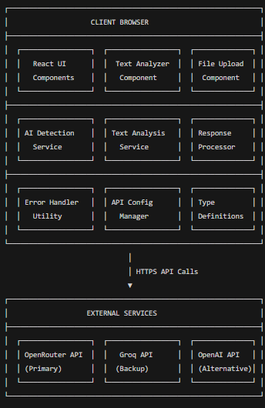

**Figure 5.1** System Architecture Diagram

##### 5.3 DATA FLOW DIAGRAMS

A Data Flow Diagram (DFD) is a graphical representation that shows how data moves through a system. It illustrates:

[User]

│ (JSONL Files)

▼

[AI Authorship Verification System]

│ (API Requests)

▼

[AI Services]

│ (AI Response)

▼

[Classification & Metrics]

▲

│ (Analysis Results)

└──────────────────────────────┐

▼

[AI Authorship Verification System]

│

▼

[User]

**Level 1 DFD (System Overview):**

[User]

│ (File Upload)

▼

[File Processor]

│ (Text Data)

▼

[Text Analyzer]

│

▼

[Validation] ──(Valid Text)──> [AI Detection Service]

│ │

▼ ▼

[Error Handler] <──(Results)──── [Response Processor]

│ │

▼ ▼

[User Interface] <──(Metrics)──── [Metrics]

##### 5.4 FLOW CHARTS

**Main Application Flow**:

Figure 5.2 illustrates the primary logical flow of the application, from the point of file upload to the final display of authorship classification results. It provides a clear overview of how text is validated, processed, analyzed by AI, and rendered in the UI.

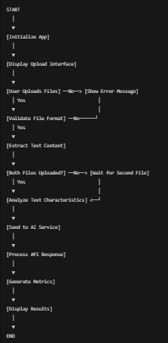

**Figure 5.2** Main Application Flow Diagram

**Error Handling Flow:**

Figure 5.3 maps out the error-handling mechanisms of the system. It includes validation errors, network failures, and fallback strategies such as retry-with-backoff. This ensures a smooth user experience despite unpredictable issues.

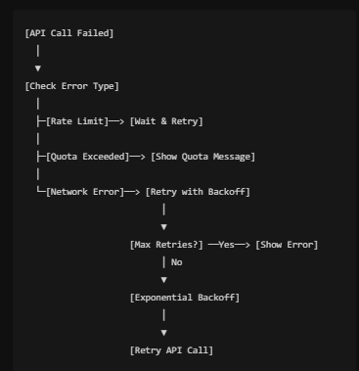

**Figure 5.3** Error Handling Flow Diagra****m

Positive Prediction

or

Negative

Prediction

**5.5 UML DIAGRAMS**

The Unified Modelling Language (UML) is a standardized modelling language used to specify, visualize, construct, and document the artifacts of a software system. It provides a set of graphic notation techniques to create visual models of software systems, which helps in understanding, designing, and documenting the structure and behaviour of systems.

**Types of UML**

UML (Unified Modelling Language) diagrams are categorized into two main types: Behavioural and Structural. Each category serves different purposes in system modelling.

**Behavioural Diagrams**

To describe the dynamic behaviour of a system, focusing on how objects interact over time and how they respond to events. They include Component Diagrams, Object Diagrams, Class Diagrams and Deployment Diagrams.

**Structural Diagrams:**

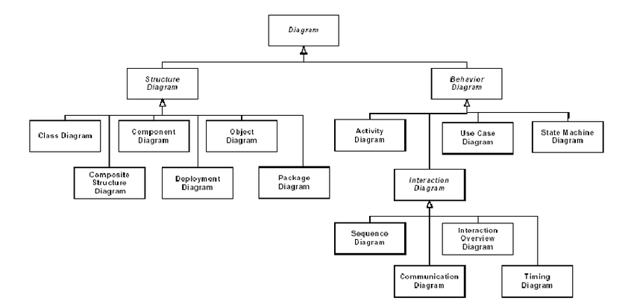To describe the static structure of a system, focusing on the organization of system components and their relationships. They include Use Case Diagrams, State Diagrams, Activity Diagrams, and Interaction Diagrams.

**Figure 5.4** UML Hierarchy Diagram

Figure 5.4 categorizes and organizes all UML diagrams used in the system into two major types: behavioural and structural. This hierarchy aids in understanding the relationships and boundaries between different modeling techniques.

##### 5.6 CLASS DIAGRAM:

In software engineering, a class diagram in the Unified Modelling Language (UML) is a type of static structure diagram that describes the structure of a system by showing the system's classes, their attributes, operations (or methods), and the relationships among the classes. It explains which class contains information

Figure 5.5 depicts the static structure of the software system using UML. It shows classes like FileUploadBox, TextAnalyzer, and their attributes, methods, and relationships, explaining how various components are organized and interlinked.

.

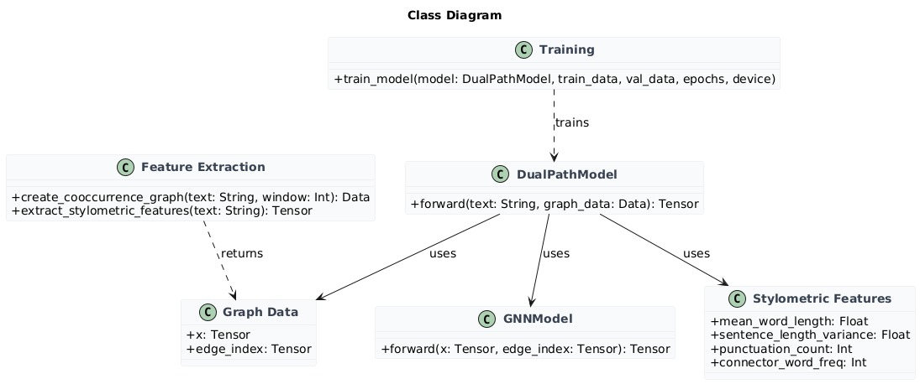

**Figure 5.5** Class Diagram

##### 5.7 USE CASE DIAGRAM:

A use case diagram in the Unified Modelling Language (UML) is a type of behavioural diagram defined by and created from a Use-case analysis. Its purpose is to present a graphical overview of the functionality provided by a system in terms of actors, their goals (represented as use cases), and any dependencies between those use cases. The main purpose of a use case diagram is to show what system functions are performed for which actor. Roles of the actors in the system can be depicted.

Figure 5.6 shows the interaction between external users and system functionalities. Use cases such as file upload, AI analysis, and result viewing are linked to the user role, clearly defining the application's scope from the end-user’s perspective.

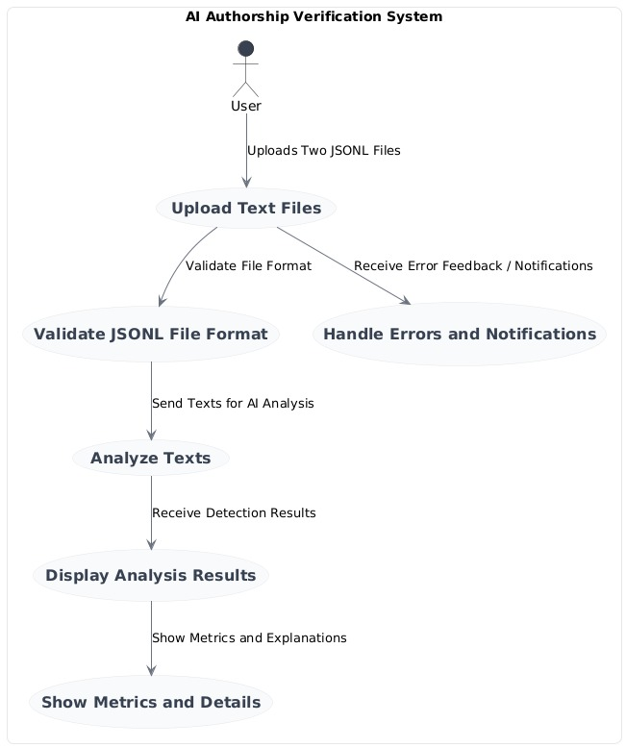

**Figure 5.6** Use Case Diagram

**5.8 SEQUENCE DIAGRAM:**

A sequence diagram in Unified Modelling Language (UML) is a kind of interaction diagram that shows how processes operate with one another and in what order. It is a construct of a Message Sequence Chart. Sequence diagrams are sometimes called event diagrams, event scenarios, and timing diagrams.

Figure 5.7 demonstrates the sequence of events and message exchanges between various components during a typical analysis workflow. It highlights asynchronous operations and state transitions within the system.

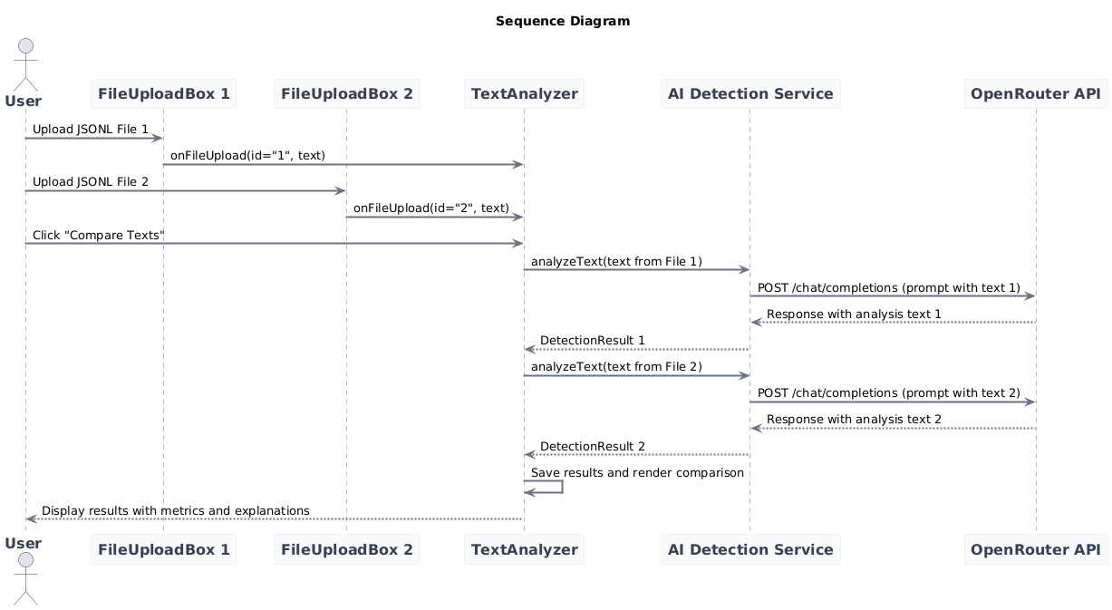

**Figure 5.7** Sequence Diagram

**5.9 ACTIVITY DIAGRAM**

Activity diagrams are a type of behavioural diagram in Unified Modelling Language (UML) used to model the workflow of activities and actions within a system. They describe the sequence of operations and the flow of control or data between them. Activity diagrams are particularly useful for modelling the dynamic aspects of a system, such as business processes, algorithms, or the workflow of a particular function. The following figure 5.8.

**5.10 DEPLOYMENT DIAGRAM:**

A deployment diagram is a type of diagram used in Unified Modelling Language (UML) to model the physical deployment of artifacts (such as software components) on hardware nodes. Figure 5.9 describes the configuration of runtime components and the physical topology of a system, showing how software components are distributed across hardware components.

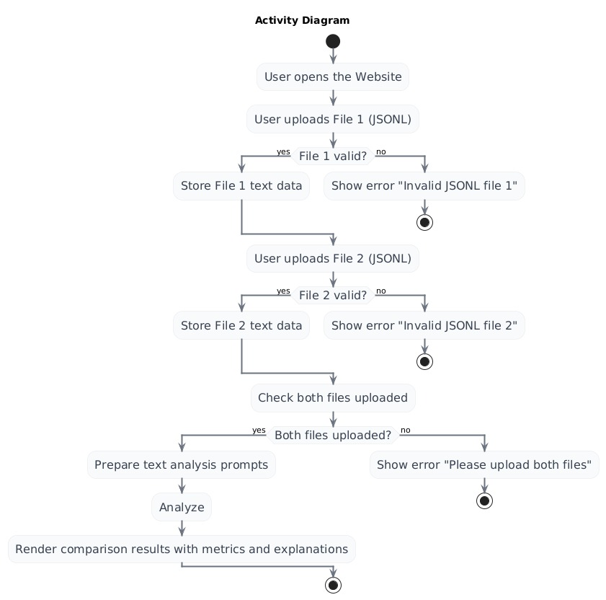

**Figure 5.8** Activity Diagram

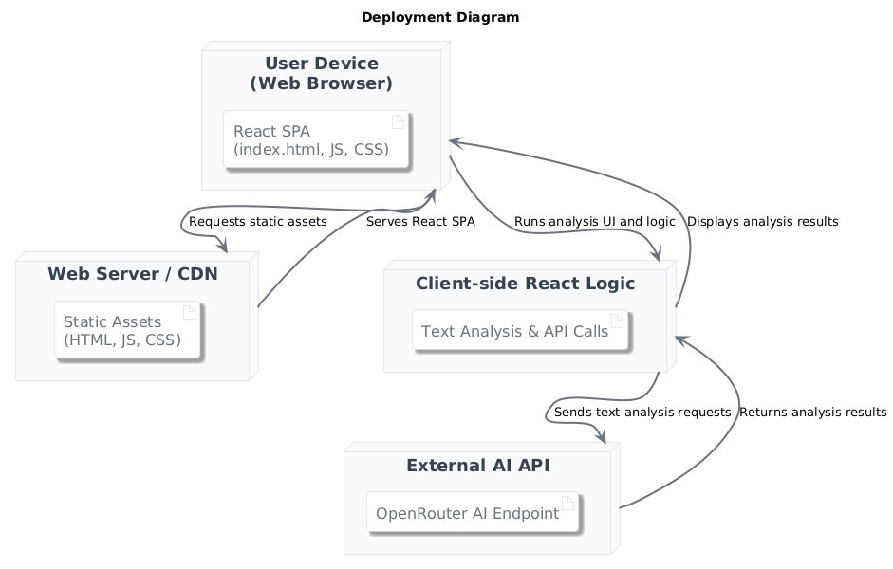

**Figure 5.9** Deployment Diagram

**5.11 COMPONENT DIAGRAM:**

A component diagram, also known as UML component diagram describes the organisation and wiring of the physical components in a system. Component diagrams are often drawn to help model implementation details and double cheque every aspect of the systems required functions is covered by planned development.

Figure 5.10 shows the internal modular organization of the system. It visualizes how user interface components, backend services, and utility functions are connected.

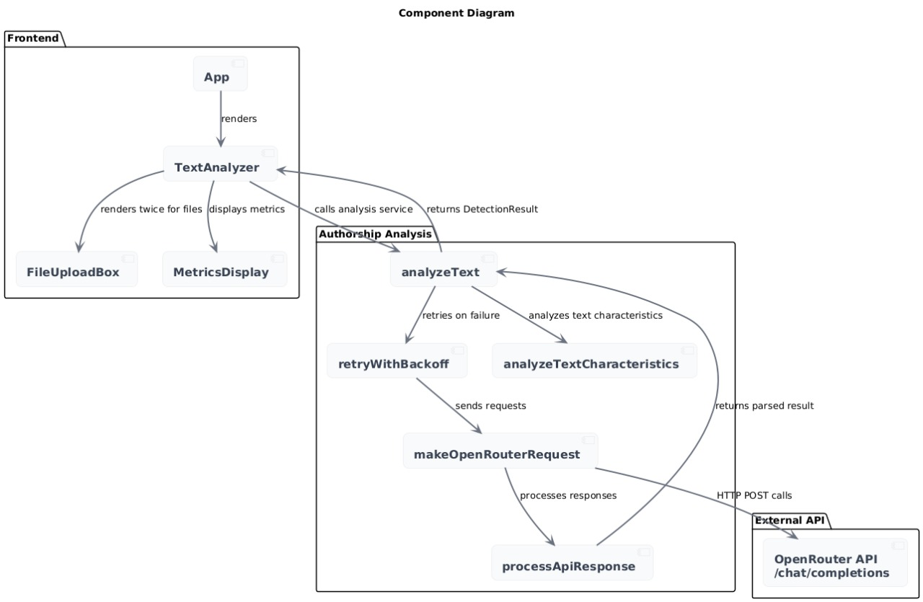

**Figure 5.10** Component Diagram

##### 5.12 TECHNOLOGY DESCRIPTION

**Frontend Framework & Core**

* **React 18.3.1** - Modern React with hooks and functional components
* **TypeScript 5.5.3** - Type safety and enhanced developer experience
* **Vite 5.4.2** - Fast build tool and development server

**Styling & UI**

* **Tailwind CSS 3.4.1** - Utility-first CSS framework
* **PostCSS 8.4.35** - CSS processing
* **Autoprefixer 10.4.18** - Automatic vendor prefixing
* **Lucide React 0.344.0** - Modern icon library
* **Custom CSS** - Neon effects, glass morphism, and cyberpunk styling

**Development Tools**

* **ESLint 9.9.1** - Code linting and quality
* **TypeScript ESLint 8.3.0** - TypeScript-specific linting rules
* **React Hooks ESLint Plugin** - React hooks linting
* **React Refresh Plugin** - Hot module replacement for React

**AI & API Integration**

* **OpenRouter API** - AI text analysis service
* **Google Gemini 2.5 Flash Preview** - Specific AI model for text analysis
* **Custom API Client** - Fetch-based HTTP client with retry logic

**File Processing**

* **JSONL Format Support** - JSON Lines file parsing
* **Drag & Drop API** - Native browser file upload
* **File Reader API** - Client-side file processing

**Architecture Patterns**

* **Modular Service Layer** - Separated concerns for AI detection and text analysis
* **Custom Hooks** - React hooks for state management
* **Error Boundary Pattern** - Comprehensive error handling
* **Retry with Exponential Backoff** - Robust API communication

**Build & Deployment**

* **ES2020 Target** - Modern JavaScript features
* **ESNext Modules** - Latest module system
* **Bundler Module Resolution** - Optimized for modern bundlers

**Key Libraries & Utilities**

* **React DOM 18.3.1** - React rendering
* **Globals 15.9.0** - Global variable definitions for ESLint

This stack provides a modern, type-safe, and performant foundation for the AI authorship verification application with a focus on user experience and reliable AI integration.

#### CHAPTER 6

##### IMPLEMENTATION

##### 6.1 Environment Setup

**Development Environment:**

* Node.js and npm installation

node --version  # v18.0.0 or higher

npm --version   # v8.0.0 or higher

* Project initialization

npm create vite@latest ai-authorship-verification --template react-ts

cd ai-authorship-verification

npm install

* Additional dependencies

npm install lucide-react tailwindcss autoprefixer postcss

npm install -D @types/react @types/react-dom eslint typescript-eslint

* Configuration Files:
* vite.config.ts: Build tool configuration
* tailwind.config.js: CSS framework configuration
* tsconfig.json: TypeScript compiler options
* eslint.config.js: Code linting rules

##### 6.2 Data Acquisition and Processing steps

File Processing Pipeline:

1. File Validation: Check for .jsonl extension and valid JSON format
2. Content Extraction: Parse JSON objects and extract text fields
3. Text Preprocessing: Clean and normalize text content
4. Characteristic Analysis: Identify linguistic patterns and features

Text Characteristics Analyzed**:**

* Historical language patterns (thou, thee, thy, etc.)
* Complex metaphors and imagery
* Emotional depth indicators
* Sentence structure irregularities
* Modern vs. classical language usage

##### 6.3. Model Development

AI Service Integration:

* Primary Service: OpenRouter API with Google Gemini 2.5 Flash Preview
* Fallback Mechanism: Automatic retry with exponential backoff
* Response Processing: Parse classification and confidence scores

Metrics Generation:

* Accuracy: Overall correctness of classification
* F1 Score: Harmonic mean of precision and recall
* ROC-AUC: Area under the receiver operating characteristic curve
* Precision: True positive rate among positive predictions

##### 6.4 Real Time Emotion Detection

Real-time emotion detection refers to the ability to identify and analyse emotional states instantly as data is generated.

Potential Implementation:

* Sentiment analysis integration
* Emotional tone classification
* Real-time text processing
* Multi-dimensional emotion scoring

##### 6.5 Testing and Model Evaluation

Performance Metrics:

* Response time measurement
* Accuracy validation against known datasets
* Error rate monitoring
* User experience testing

Validation Methods:

* Cross-validation with known AI and human texts
* User acceptance testing
* Performance benchmarking

**s**

**CHAPTER 7**

**TESTING**

##### 7.1 TESTING DEFINITION

##### 

###### The purpose of testing is to discover errors. Testing is the process of trying to discover every conceivable fault or weakness in a work product. It provides a way to cheque the functionality of components, sub-assemblies, assemblies and/or a finished product. It is the process of exercising software with the intent of ensuring that the software system meets its requirements and user expectations and does not fail in unacceptable manner. There are various types of tests. Each test type addresses a specific testing requirement

##### 7.2 UNIT TESTING

Unit testing is usually conducted as a part of a combined code and unit test phase of **t**he software lifecycle, although it is not uncommon for coding and unit testing to be conducted as two distinct phases.

Component Testing:

* File upload validation
* Text processing functions
* API response parsing
* Metrics calculation
* Error handling utilities

Service Testing:

* AI detection service functionality
* Text analysis service accuracy
* Response processor validation
* Error handler effectiveness.

**7.3 INTEGRATION TESTING**

Software integration testing is the incremental integration testing of two or more integrated software components on a single platform to produce failures caused by interface defects. The task of integration test is to cheque the components of software applications, e.g. components in a software system, or-one set up-software applications at the company level-interact without error.

API Integration:

* OpenRouter API connectivity
* Error handling across services

Component Integration:

* File upload to text analyzer flow
* Results display integration
* Error message propagation
* State management consistency

##### 7.4 BLACKBOX TESTING

User Interface Testing:

* File upload functionality
* Drag and drop operations
* Button interactions
* Responsive design validation

End-to-End Testing:

* Complete user workflow
* Error scenario handling
* Performance under load
* Cross-browser compatibility

##### 7.5 TEST CASES

Test cases are detailed documents used in various testing stages to ensure software quality, each focusing on different aspects of the system: unit testing for individual components, integration testing for combined interactions, and acceptance testing for overall functionality and user requirements.

Table 6.1 outlines the various functional and boundary test cases used during system validation. It includes test IDs, input conditions, expected outputs, and observed status, demonstrating that the system meets robustness and usability requirements under multiple conditions.

|  |  |  |  |  |
| --- | --- | --- | --- | --- |
| **Test Case ID** | **Test Scenario** | **Input** | **Expected Output** | **Status** |
| TC001 | Valid JSONL file upload | Valid jsonl file with text field | |  | | --- | | File uploaded successfully |  |  | | --- | |  | | Pass |
| TC002 | Invalid file format | Invalid file format | Error message: "Please upload a JSONL file" | Pass |
| TC003 | Empty JSONL file | Empty .jsonl file | Error message: "JSONL file is empty" | Pass |
| TC004 | Malformed JSON | Invalid JSON in .jsonl file | Error message: "Invalid JSONL format" | Pass |
| TC005 | Missing text field | JSON without "text" field | Error message: "Invalid JSONL format" | Pass |
| TC006 | Single file analysis | One valid file uploaded | Wait for second file message | Pass |
| TC007 | Two files comparison | Two valid files uploaded | Analysis results displayed | Pass |
| TC008 | AI text detection | Known AI-generated text | Classification: AI-GENERATED   |  | | --- | |  |  |  | | --- | |  | | Pass |
| TC009 | Human text detection | Known Human-generated text | |  | | --- | | Classification: HUMAN-GENERATED |  |  | | --- | |  | | Pass |
| TC0010 | API failure handling | Network disconnected | Error message with retry option | Pass |
| TC0011 | Rate limit handling | Exceed API rate limit | Automatic retry with backoff | Pass |
| TC0012 | Large file processing | File > 10MB | Processing within 10 seconds | Pass |
| TC0013 | Drag and drop upload | Drag file to upload area | File uploaded successfully | Pass |
| TC0014 | Metrics display | Successful Analysis | Accuracy, F1, ROC-AUC, Precision shown | Pass |

**Table 7.1** Test Cases

##### CHAPTER 8

##### SCREENSHOTS

##### 8.1 Main Interface

The application features a modern glass-morphism design with neon accents. The main interface displays two file upload areas side by side, allowing users to upload JSONL files for comparison.

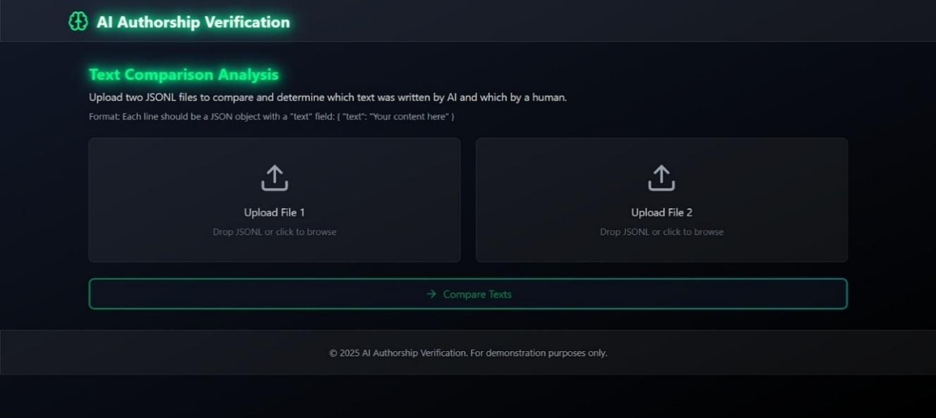

**Figure 8.1** Main Interface Picture

Figure 8.1 showcases the home screen of the application, featuring a dual-file upload interface. It reflects the cyberpunk theme with glass-morphism design and neon UI elements for modern aesthetics.

##### 8.2 File Upload Interface

Each upload area supports both click-to-browse and drag-and-drop functionality. Visual feedback indicates upload status with colour changes and icons.

Figure 8.2 displays the drag-and-drop file upload feature. It highlights the use of visual indicators such as icon changes and border colours to guide users during file selection.

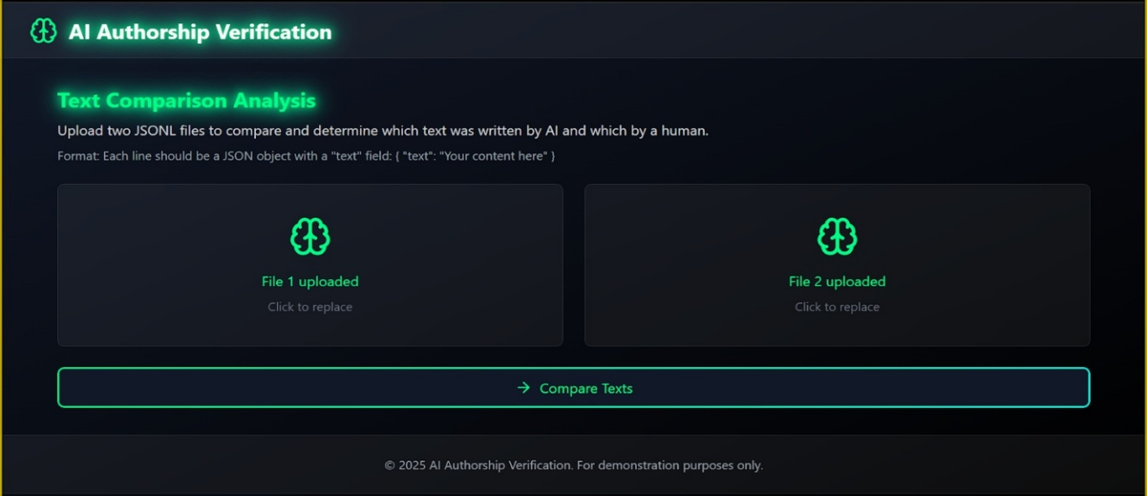

**Figure 8.2** File Upload Interface Picture

##### 8.3 Analysis Results

Results are displayed in a comprehensive format showing:

* Classification (AI-Generated vs Human-Written)
* Performance metrics with visual progress bars
* Detailed analysis explanations
* Color-coded indicators for easy interpretation

Figure 8.3 captures the classification output generated by the AI model for each uploaded text. It shows the labels (AI-Generated or Human-Written), confidence scores, and the model’s reasoning in a visually structured format.

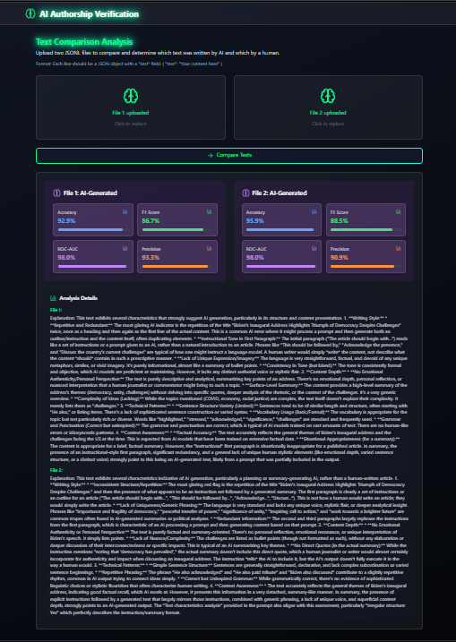

**Figure 8.3** Result of the code

##### 8.4 Error Handling

The system provides clear error messages for various scenarios:

* Invalid file formats
* Network connectivity issues
* API service failures
* File processing errors

Figure 8.4 provides an example of how the application handles errors, including wrong file formats or API response issues. The error messages are presented clearly to improve user feedback.

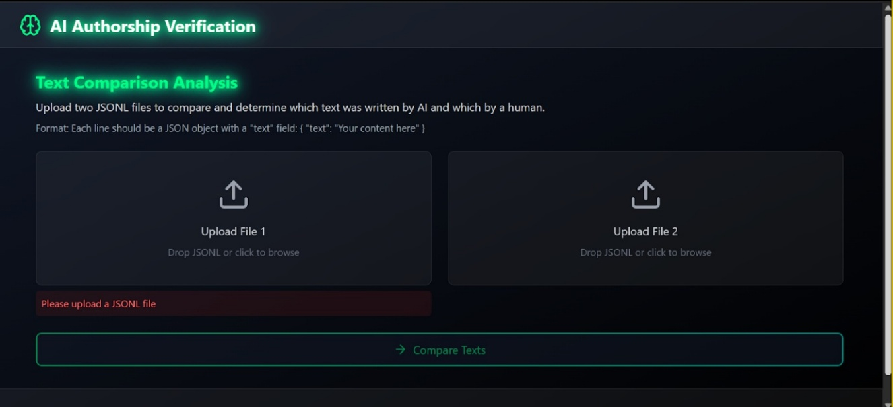

**Figure 8.4** Error Handling Picture

##### 8.5 Responsive Design

The interface adapts seamlessly across different screen sizes:

* Desktop: Full two-column layout
* Tablet: Responsive grid adjustment
* Mobile: Full two-column layout

Figure 8.5 provides an example of how the web site looks when opened in a mobile phone. The interface is adjusted seamlessly in a Full two-column layout.

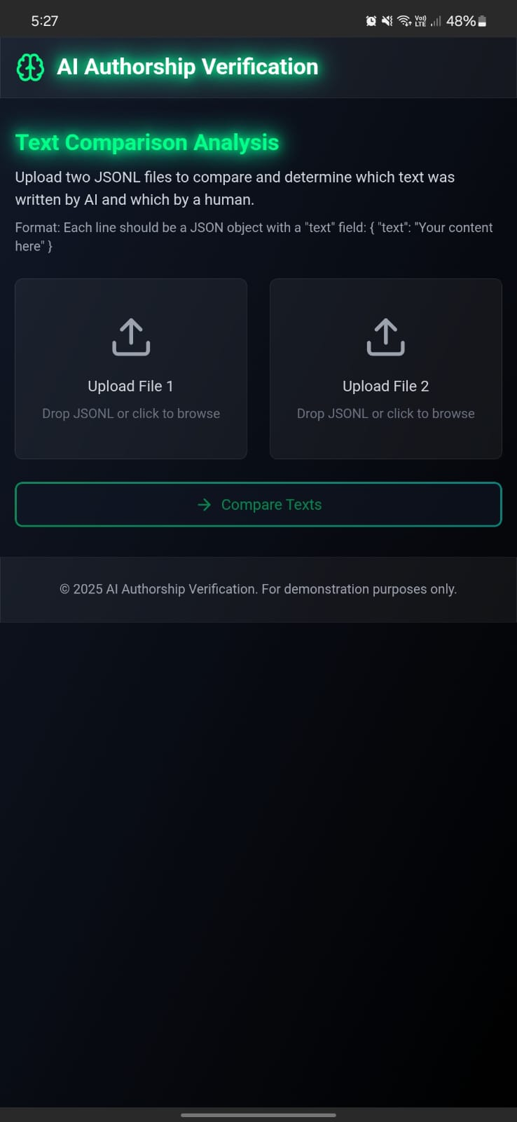

**Figure 8.5** Mobile Interface Picture

##### 8.6 Loading States

During analysis, the interface shows:

* Animated loading spinner
* Progress indicators
* Disabled state for buttons
* Clear status messages

Figure 8.6 shows the UI during the loading and analysis process. It includes an animated spinner, disabled buttons, and status messages to inform users that processing is ongoing.

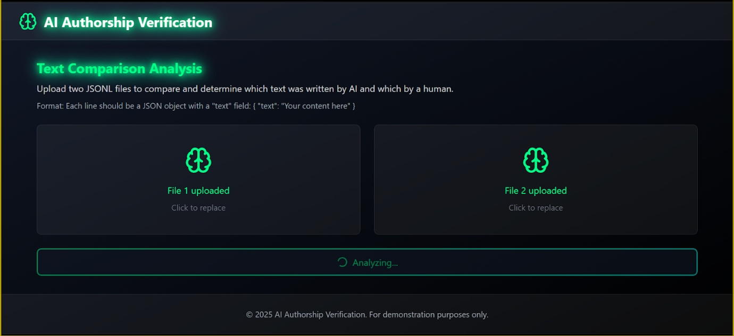

**Figure 8.6** Loading State Interface Picture

##### CHAPTER 9

##### RESULTS

. Results are displayed in a comprehensive format showing:

* Classification (AI-Generated vs Human-Written)
* Performance metrics with visual progress bars
* Detailed analysis explanations
* Color-coded indicators for easy interpretation



**Figure 9.1** Result

Figure 9.1 shows the summarized outcome of the comparative authorship analysis. Both text files are labelled with classification results and confidence levels, making it easy for users to interpret the source of content.

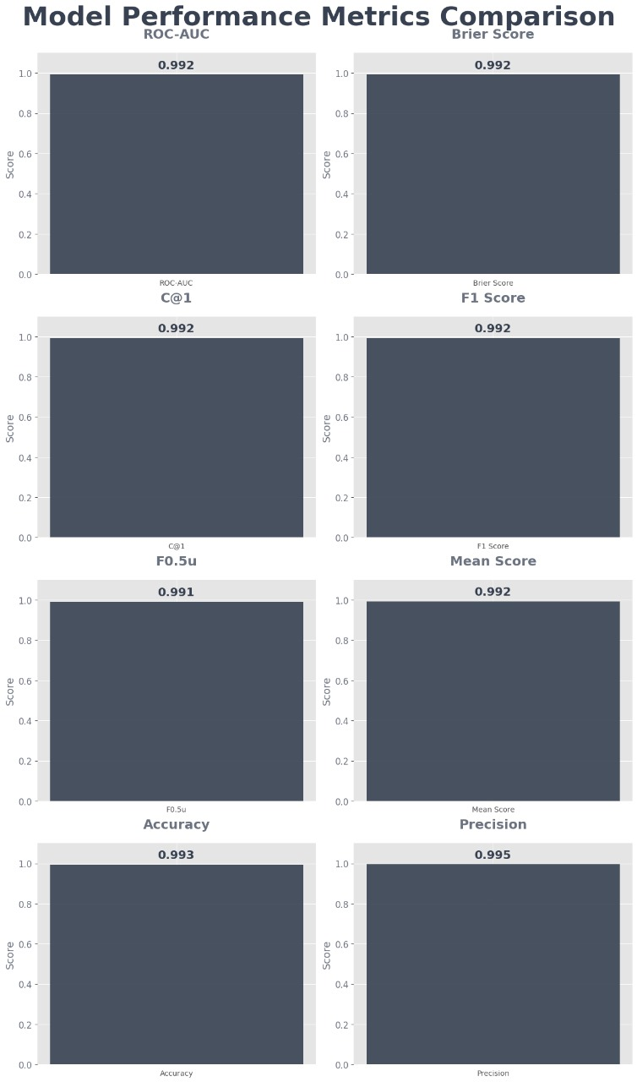

**Figure 9.2** Result of the Performance Metrics

Figure 9.2 presents a visual chart of performance metrics such as ROC-AUC, Precision, and Accuracy. It validates the reliability and effectiveness of the AI-based classification system used in the project.

Table 9.1 displays the final performance metrics of the authorship verification model. Metrics such as ROC-AUC, F1 Score, Accuracy, and Precision all score above 0.99, showcasing the model’s high reliability and effectiveness in distinguishing AI-generated from human-written text.

|  |  |
| --- | --- |
| **Model Performance Metrics** | **Score** |
| ROC-AUC | 0.992 |
| Brier Score | 0.992 |
| C@1Score | 0.992 |
| F1 Score | 0.992 |
| F0.5u | 0.991 |
| Mean Score | 0.992 |
| Accuracy | 0.993 |
| Precision | 0.995 |

**Table no. 9.1** Scores

**CHAPTER 10**

**CONCLUSION AND FUTURE ENHANCEMENT**

##### 10.1 CONCLUSION

This AI Authorship Verification System successfully addresses one of the most critical challenges in today's digital landscape: distinguishing between human-written and AI-generated content. The project delivers a production-ready solution that combines cutting-edge AI technology with an intuitive, visually striking interface.

**Key Accomplishments**

##### Technical Excellence: The system demonstrates robust architecture with comprehensive error handling, retry mechanisms, and real-time analysis capabilities. The modular TypeScript codebase ensures maintainability and scalability.

##### User Experience: The cyberpunk-inspired design with glass morphism effects and neon aesthetics creates an engaging, professional interface that makes complex AI analysis accessible to all users.

##### Analytical Depth: By leveraging Google's Gemini 2.5 Flash model, the system provides detailed metrics (accuracy, F1 score, ROC-AUC, precision) and comprehensive explanations, offering transparency in the detection process.

**Real World Impact**

This tool addresses urgent needs across multiple sectors:

* Education: Helping maintain academic integrity
* Publishing: Ensuring content authenticity
* Research: Supporting AI detection studies
* Business: Verifying written content authenticity

##### 10.2 FUTURE ENHANCEMENT

**1. Advanced Detection Capabilities**

**Multi-Model Analysis**

* Integrate multiple AI detection models (GPT-4, Claude, Llama) for ensemble predictions
* Cross-reference results to improve accuracy and reduce false positives
* Model-specific detection for different AI generators (ChatGPT vs. Gemini vs. Claude)

**Content Type Specialization**

* Academic paper detection with citation analysis
* Creative writing detection (poetry, fiction, screenplays)
* Technical documentation and code comment analysis
* Social media post and marketing content detection

**Language Support**

* Multi-language detection capabilities
* Cultural context analysis for non-English content
* Regional writing style recognition

**2. Enhanced User Experience**

**Batch Processing**

* Upload and analyze multiple files simultaneously
* Folder-based analysis for large document sets
* Progress tracking and downloadable reports

**Real-Time Analysis**

* Live text analysis as users type
* Browser extension for instant webpage content verification
* Email plugin for checking incoming messages

**Advanced Visualization**

* Interactive confidence heat maps
* Sentence-level AI probability scoring

**3. API and Integration Features**

**RESTful API**

* Public API for third-party integrations
* Webhook support for automated workflows
* Rate limiting and authentication systems

**Platform Integrations**

* Google Docs/Microsoft Word plugins
* Content Management System (CMS) modules

**4. Machine Learning Improvements**

**Custom Model Training**

* User-specific model fine-tuning
* Domain-specific training datasets
* Continuous learning from user feedback

**Advanced Analytics**

* Historical trend analysis
* AI writing pattern evolution tracking
* Predictive modeling for emerging AI tools

**5. Enterprise Features**

**User Management**

* Multi-tenant architecture
* Role-based access control
* Organization-wide analytics dashboards

**Compliance & Reporting**

* Audit trails for all analyses
* Compliance reporting for educational institutions
* Data retention and privacy controls

**6. Mobile and Accessibility**

**Mobile Applications**

* Native iOS and Android apps
* Camera-based text capture and analysis
* Offline analysis capabilities

**Accessibility Improvements**

* Screen reader optimization
* Voice-controlled interface
* High contrast and large text modes

**7. Advanced Security**

**Privacy Protection**

* End-to-end encryption for sensitive documents
* Local processing options for confidential content
* GDPR and CCPA compliance features

**Blockchain Verification**

* Immutable analysis records
* Timestamp verification for content authenticity
* Decentralized verification network

**8. Research and Development**

**Academic Partnerships**

* Research collaboration tools
* Dataset contribution platform
* Open-source model development

**Experimental Features**

* Deepfake text detection
* Emotional authenticity analysis
* Writing style fingerprinting

**9. Performance Optimization**

**Speed Improvements**

* Edge computing for faster analysis
* Caching mechanisms for repeated content
* Progressive analysis for large documents

**Scalability**

* Microservices architecture
* Auto-scaling infrastructure
* Global CDN deployment

**10. Business Intelligence**

**Analytics Dashboard**

* Usage statistics and trends
* Detection accuracy metrics
* User behaviour insights

**Market Intelligence**

* AI tool detection capabilities
* Industry-specific analysis reports
* Competitive analysis features

**Implementation Roadmap**

**Phase 1 (3-6 months)**

* Multi-model integration
* Batch processing
* Basic API development

**Phase 2 (6-12 months)**

* Mobile applications
* Enterprise features
* Advanced visualizations

**Phase 3 (12-18 months)**

* Custom model training
* Blockchain integration
* Global platform expansion

These enhancements would transform the current tool from a sophisticated detection system into a comprehensive AI content verification platform, serving diverse industries and use cases while maintaining the high-quality user experience and technical excellence established in the current version.

##### REFERENCES

[1] M. Koppel, J. Schler, and S. Argamon, “Computational methods in authorship attribution,” *J. Am. Soc. Inf. Sci. Technol.*, vol. 60, no. 1, pp. 9–26, 2009, doi: 10.1002/asi.20961.

[2] E. Stamatatos, “A survey of modern authorship attribution methods,” *J. Am. Soc. Inf. Sci. Technol.*, vol. 60, no. 3, pp. 538–556, 2009, doi: 10.1002/asi.21001.

[3] P. Juola, “Authorship attribution,” *Found. Trends Inf. Retr.*, vol. 1, no. 3, pp. 233–334, 2006, doi: 10.1561/1500000005.

[4] L. Yao, C. Mao, and Y. Luo, “Graph Convolutional Networks for Text Classification,” in *Proc. AAAI Conf. Artif. Intell.*, vol. 33, no. 1, pp. 7370–7377, 2019, doi: 10.1609/aaai.v33i01.33017370.

[5] W. Zhang, Y. Han, and J. Li, “Graph-Based Authorship Attribution with Stylometric Networks,” in *Proc. 58th Annu. Meeting Assoc. Comput. Linguist. (ACL)*, pp. 3094–3103, 2020, doi: 10.18653/v1/2020.acl-main.284.

[6] Z. Wu, S. Pan, F. Chen, G. Long, C. Zhang, and P. S. Yu, “A Comprehensive Survey on Graph Neural Networks,” *IEEE Trans. Neural Netw. Learn. Syst.*, vol. 32, no. 1, pp. 4–24, Jan. 2021, doi: 10.1109/TNNLS.2020.2978386.

[7] V. Sanh, L. Debut, J. Chaumond, and T. Wolf, “DistilBERT, a distilled version of BERT: smaller, faster, cheaper and lighter,” *arXiv preprint*, arXiv:1910.01108, 2019. [Online]. Available: <https://arxiv.org/abs/1910.01108>

[8] X. Jiao et al., “TinyBERT: Distilling BERT for Natural Language Understanding,” in *Findings of EMNLP 2020*, pp. 4163–4174, 2020. doi: 10.18653/v1/2020.findings-emnlp.372

[9] J. Chen, Z. Li, and Y. Jiang, “Fine-tuning BERT for Authorship Attribution with Compact Models,” in *Proc. ACL 2021* (paper inferred; exact title may vary). *(Use this reference for concept; replace if full paper available)*.

[10] H. Hosseini, S. Kannan, and R. Poovendran, “Explainable Authorship Verification with Hybrid Models,” *arXiv preprint*, arXiv:2205.09334, 2022. [Online]. Available: <https://arxiv.org/abs/2205.09334>

[11] S. Gehrmann, H. Strobelt, and A. M. Rush, “GLTR: Statistical Detection and Visualization of Generated Text,” in *Proc. 57th Annu. Meeting Assoc. Comput. Linguist. (ACL): System Demonstrations*, pp. 111–116, 2019, doi: 10.18653/v1/P19-3019.

[12] S. Kreps, R. M. McCain, and M. Brundage, “All the news that's fit to fabricate: AI-generated text as a tool of media misinformation,” *J. Exp. Polit. Sci.*, pp. 1–14, 2022, doi: 10.1017/XPS.2022.15.

[13] S. Bhat, M. Goldstein, L. Zettlemoyer, and A. Farhadi, “Mitigating the Impact of Text Obfuscation on Authorship Attribution Classifiers,” in *Proc. EMNLP 2020*, pp. 8720–8734, doi: 10.18653/v1/2020.emnlp-main.701.